

Scale-Out Process Servers – VMWare/Physical Environments

10th Magnitude, LLC
20 North Wacker Drive #530
Chicago, IL 60606

Notice of Confidentiality © 2018 10th Magnitude, LLC All rights reserved

THIS DOCUMENT IS 10TH MAGNITUDE PROPRIETARY AND CONFIDENTIAL INFORMATION AND IS SUBJECT TO THE TERMS OF THE 10TH MAGNITUDE NON-DISCLOSURE AGREEMENT. NEITHER THIS DOCUMENT NOR ITS CONTENTS MAY BE REVEALED OR DISCLOSED TO UNAUTHORIZED PERSONS OR SENT OUTSIDE THE AFOREMENTIONED COMPANY WITHOUT PRIOR PERMISSION FROM 10TH MAGNITUDE.
Table of Contents
Summary 3
Capacity Planning 4
Hardware Requirements 4
Software Requirements 4
Network Requirements 5
Deployment 5
Download Installation File 5
Generate Passphrase 7
Installation 7
Post Installation Verification 12

Summary
This document is intended to serve as a guide to ensure the prerequisites are met to scale out an existing Azure Site Recovery infrastructure as well as to help guide you through the process of executing a deployment to expand your Azure Site Recovery infrastructure. The information and checklists in this document are not exhaustive, they only contain common scenario information.
General ASR documentation:
https://docs.microsoft.com/en-us/azure/site-recovery/

ASR capacity planning guide:
https://docs.microsoft.com/en-us/azure/cloud-solution-provider/migration/on-premises-to-azure-csp/asr-capacity-planning

ASR setup guides:
https://docs.microsoft.com/en-us/azure/cloud-solution-provider/migration/on-premises-to-azure-csp/asr-setup-guide

Process Server Setup:
https://docs.microsoft.com/en-us/azure/site-recovery/vmware-azure-set-up-process-server-scale

Deployment Planner:
https://docs.microsoft.com/en-us/azure/site-recovery/site-recovery-deployment-planner

Capacity Planning
Capacity planning will allow you to determine how many servers are needed to expand your current on-premises ASR infrastructure. Deployment Planner is the primary tool used by 10th Magnitude’s Cloud Migration Center to determine bandwidth, RPO, and costs associated with groups of servers that are in scope for a lift & shift migration.
Deployment Planner documentation can be found on our internal SharePoint site here.
Additional information about Deployment Planner can be found in a link listed above.

Hardware Requirements
Determining the resources required for each additional server depends on the total amount of servers that will be replicated and total daily churn rate. There are three sizing recommendations based on the those two factors.
Approx. Protected Machines | CPU/RAM | Cache disk size | Daily Data Change Rate
Replicate ≤ 85 machines | 4 vCPU/8GB | 300GB | ≤ 250GB
Replicate 85-150 machines | 8 vCPU/16GB | 600GB | 250-1TB
Replicate 150-225 machines | 12 vCPU/24Gb | 1TB | 1-2TB

An example of a single scale-out process server configuration for an environment that will replicate approximately 85-150 machines would look like this:
CPU Cores | 8
RAM | 16GB
Number Of Disks | 3 disks total – OS, process server cache disk, and retention drive for failback
Free disk space required (process server cache) | 600GB
Free disk space (retention disk) | 600GB

Software Requirements

Operating System | Windows Server 2012 R2 or Windows Server 2016
Operating System Locale | English (en-*)
Windows Server Roles | These roles should NOT be enabled on the server:  -Active Directory Domain Services  -Internet Information Services  -Hyper-V
Group Policies | These policies should NOT be enabled:  -Prevent access to the command prompt  -Prevent access to the registry editing tools  -Trust logic for file attachments  -Turn on Script Execution
IIS | -No pre-exisiting default website  -No pre-existing website/application listening on port 443  -Enable anonymous authentication  -Enable FastCGI setting
FIPs (Federal Infromation Processing Standards) | Do not enable FIPS mode
Additional Required Software | -PowerCLI version 6.0  -MYSQL
.NET Framework version | ≥ 4.6.2

Network Requirements
IP Address Type | Static
Ports | 443  9443
NIC Type | VMWare VM – VMXNET3
Internet Access to the following URLs | *.backup.windowsazure.com  *.blob.core.windows.net  *.hypervrecoverymanager.windowsazure.com  https://login.microsoftonline.com  time.nist.gov  time.windows.com  https://management.azure.com  https://secure.aadcdn.microsoftonline-p.com  https://login.live.com  https://graph.windows.net  https://login.windows.net  *.services.visualstudio.com (Optional)  https://www.live.com  https://www.microsoft.com  https://dev.mysql.com/get/Downloads/MySQLInstaller/mysql-installer-community-5.7.20.0.msi

Deployment

Download Installation File
- Sign into the Azure Portal and navigate to the Recovery Services Vault
- Navigate to Site Recovery Infrastructure > Configuration Servers > Select the Server name that you want to add the additional Process servers too
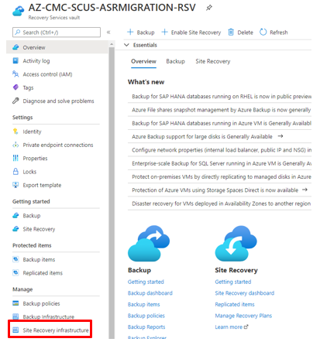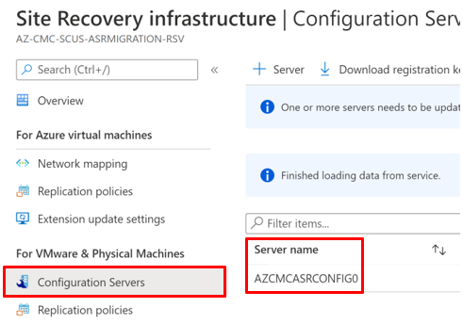
- In the details page of the Configuration server you selected, click +Process Server
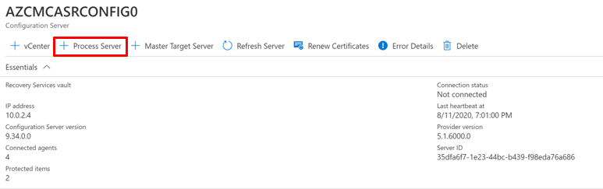
- Choose where you want to deploy your process server* - Select Deploy a scale out process server on-premises
- Click Download for the Microsoft Azure Site Recovery Unified Setup – the size of the download file is approximately 2GB
  - This can be downloaded directly on the server OR on your local machine and be copied over to the server
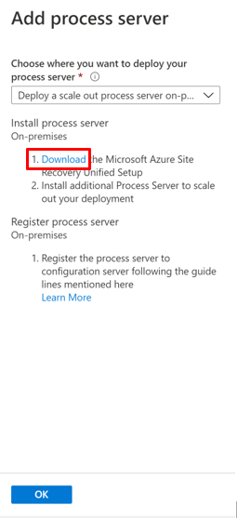

Generate Passphrase
- Log into Configuration Server
- Open Command Prompt
  - Change the directory to:
    - ‘[ASR Install Directory]\home\svsystems\bin\’ and run ‘genpassphrase.exe -n’
Note: The default install location for ASR is ‘E:\Program Files(x86) \Microsoft Azure Site Recovery’
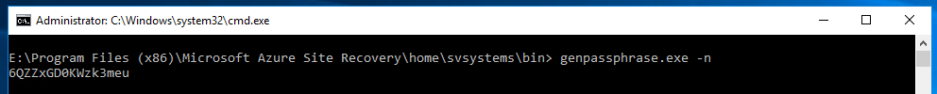
- Save the passphrase to a notepad.
  - This passphrase is going to be used during the Installation portion of this process

Installation
- Run the Microsoft Azure Site Recovery Unified Setup on the newly created server
- On the Before You Begin page, select Add additional process servers to scale out deployment
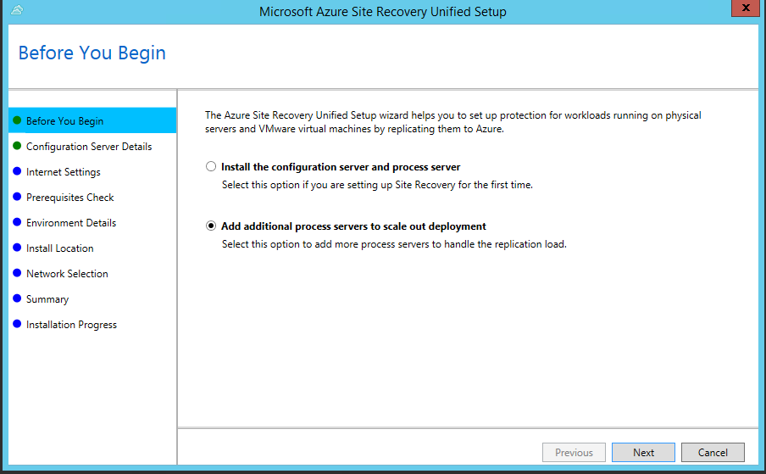
- On the Configuration Server Details page, provide the Configuration Server IP address and passphrase
  - Note: How to generate a passphrase can be found here
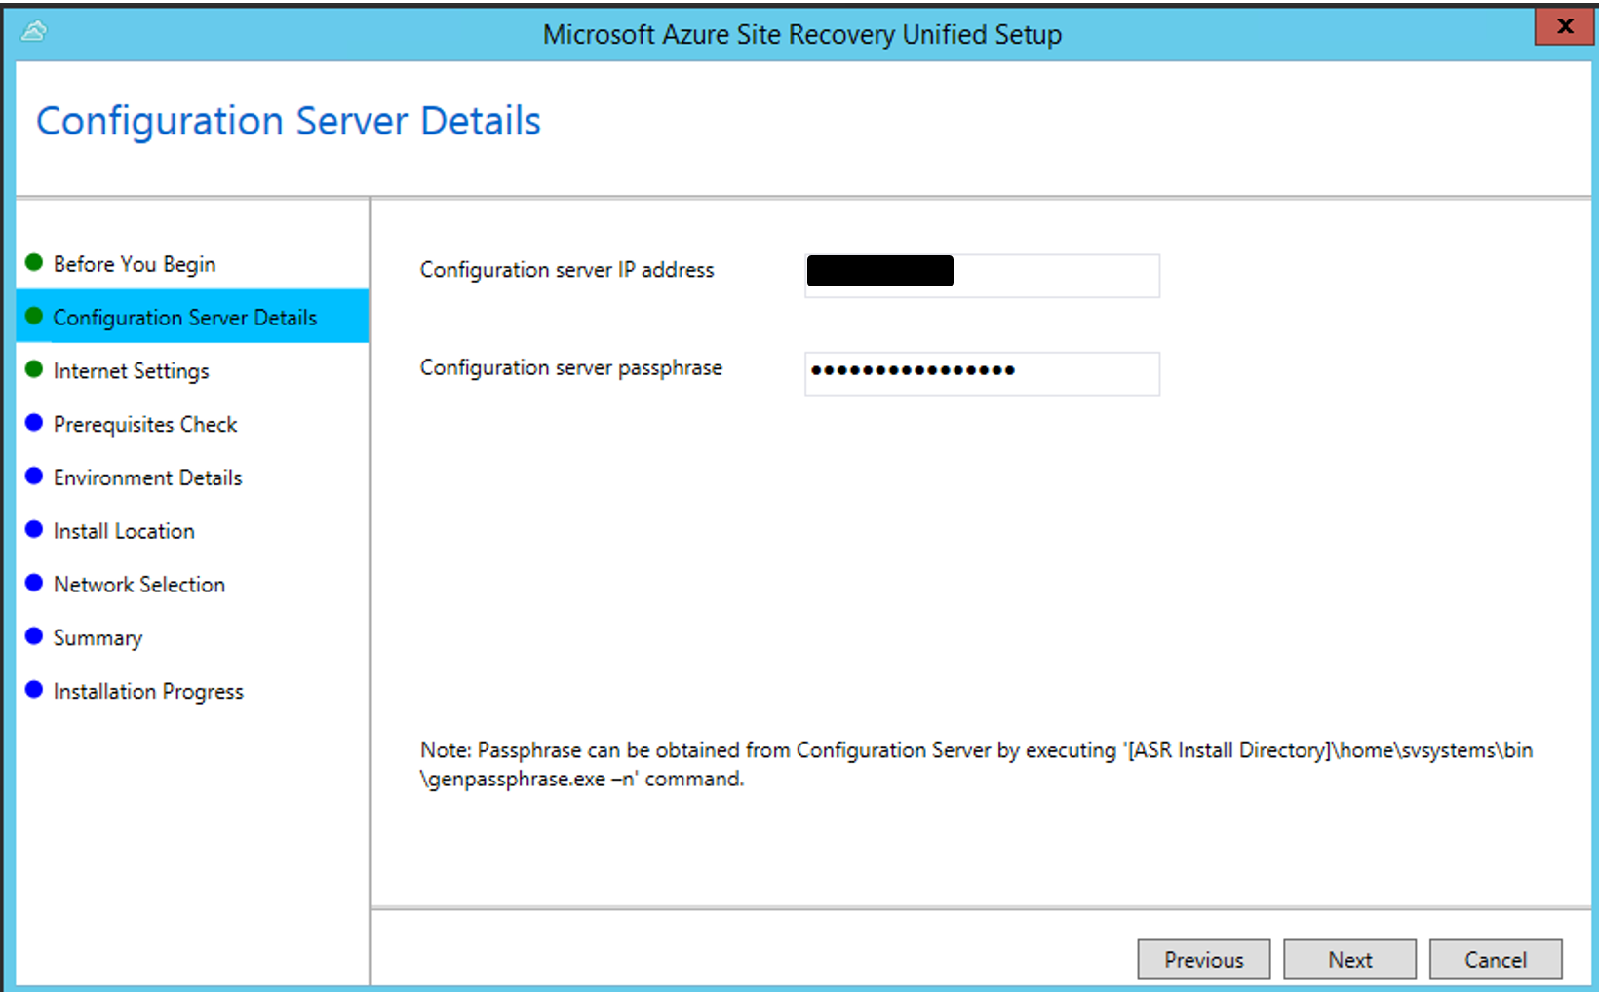
- On the Internet Connection page, select Connect directly to Azure Site Recovery without proxy server
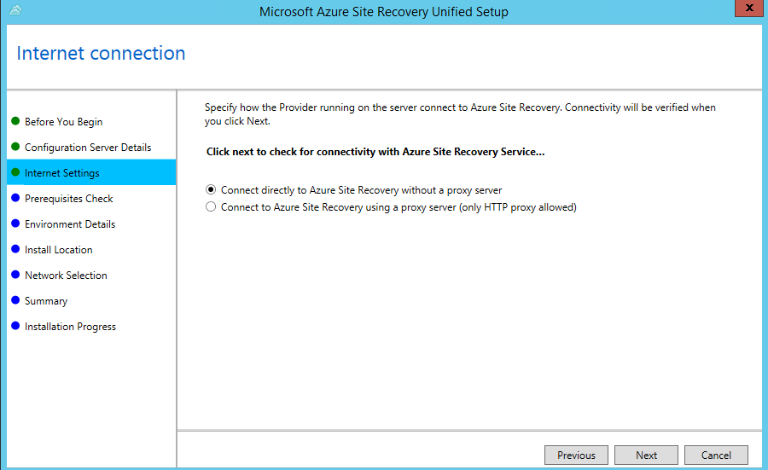
- On the Prerequisites Check page, allow these to run automatically. If there are any failures, mitigate the issue and re run.
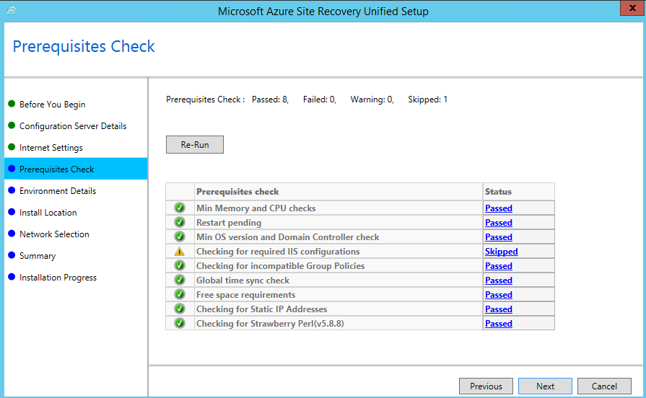
- On the Environment Details page, select Yes for VMWare environments. This step will check if VMWare Tools are installed.
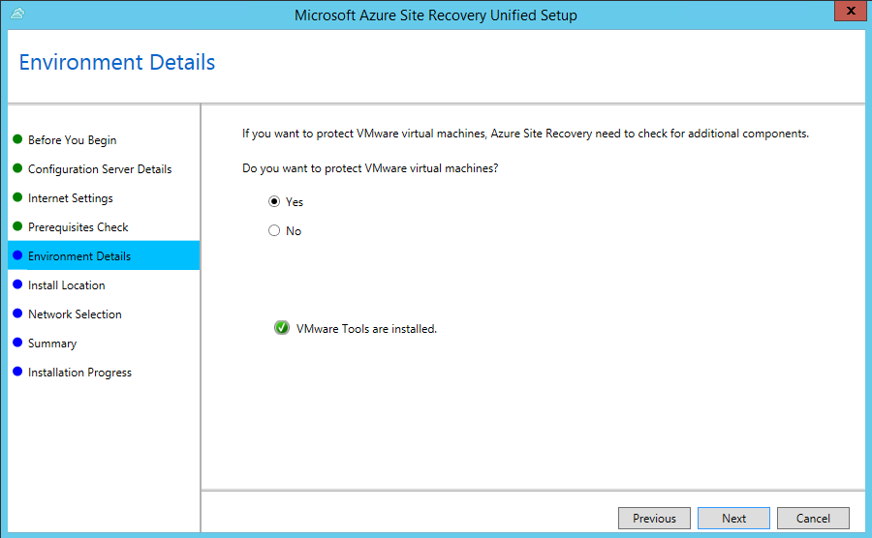
- Select the Install Location – Default is E:\Program Files(x86)\Microsoft Azure Site Recovery
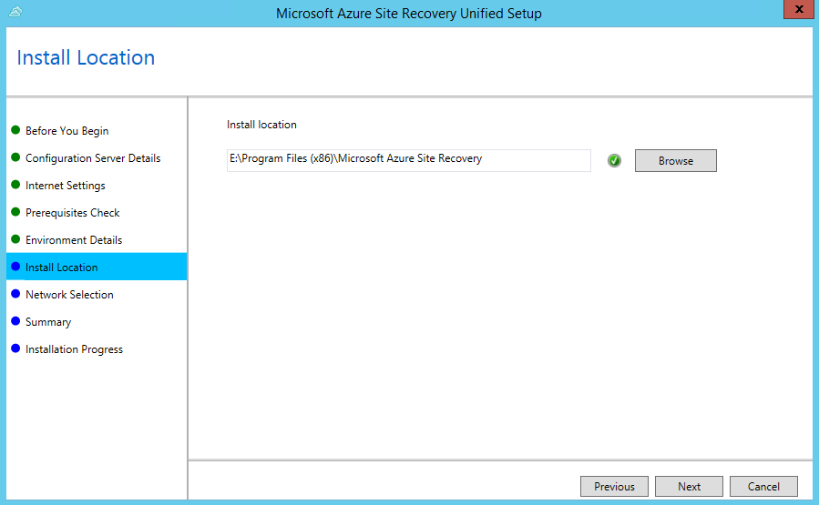
- On the Network Selection page, select the network interface that will be used to connect to the On-Premises machines.
  - The default port for replication traffic is 9443
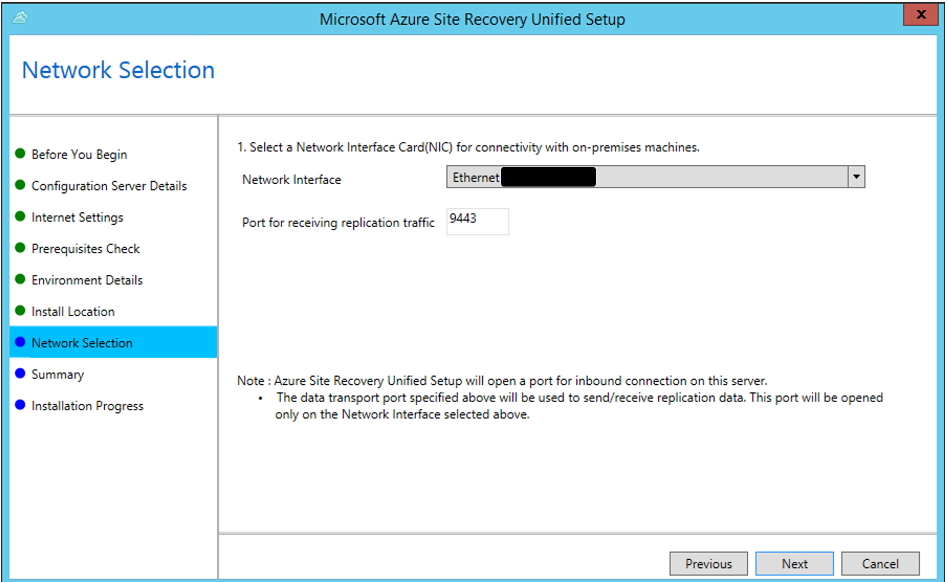
- Review the Summary page and click Install
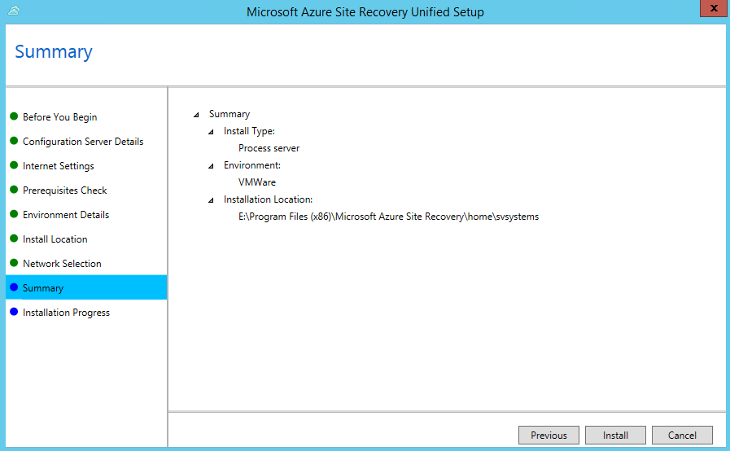
- The installation process should take approximately 15-30 minutes after going through the configuration of each step.
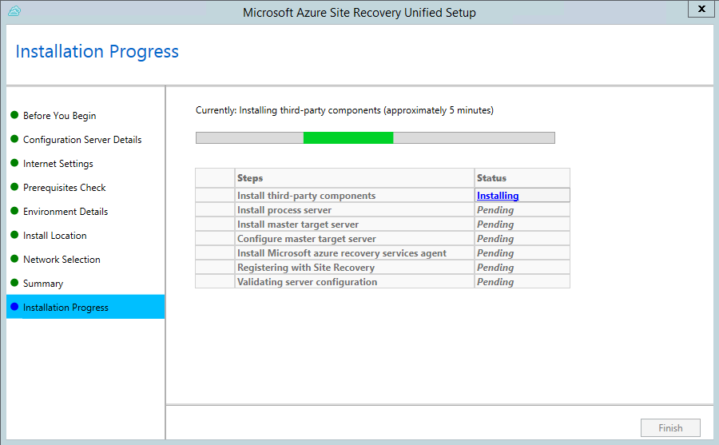
- After installation has completed, click Finish
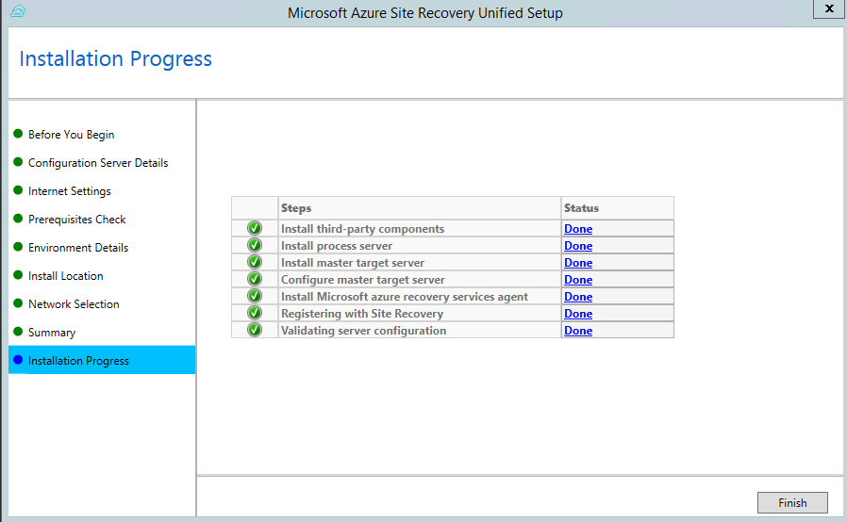

Post Installation Verification
Verify that the server you configured is registered in the correct vault:
- Navigate to the Azure Portal
- Search for your recovery services vault
- Navigate to Site Recovery Infrastructure > Configuration Servers > Select the Configuration Server you just added the additional process server to
- Click Refresh Server and the name of the additional process server will be populated in the Associated Servers section.
